TEMASEK POLYTECHNIC

SCHOOL OF INFORMATICS & IT

Diploma in Cybersecurity & Digital Forensics
AY 2022/2023 CASE STUDY (PART II)

(April Semester)

ETHICAL HACKING AND INTRUSION PREVENTION (CCD2C03)

TIME ALLOWED: REFER TO TEACHING PLAN

INSTRUCTIONS TO CANDIDATES

- This assignment consists of 6 pages (excluding cover page)

- This component is an individual component, and it contributes 30% of the overall subject grade.

- This document only provides information for Part II of the Case Study.

Contents
1. Part II – Vulnerability Assessment and Penetration Test 2
1.1 Project Overview 2
1.2 General Requirements 2
1.3 Project Report Requirements 4
1.4 Submission Instructions 5
1.5 Presentation Requirements 6

1. Part II – Vulnerability Assessment and Penetration Test

Project Overview

CDF Artworks Pte Ltd is a Singapore-based SME that is well-known for displaying high-profile artwork in a virtual setting. The business has just won a local productivity award using cloud technologies to run their virtual gallery platform called ‘The Artisan’s Gallery’.

The Client had called (as part of an annual internal review) a tender to perform a Vulnerability Assessment and Penetration Test (VAPT) on a specific set of assets hosted on the Staging environment, before they are pushed to the production cloud. However, the Staging environment is only accessible during office hours. Therefore, the Client has stated that no testing should be done during the weekends without authorization.

The awarded vendor is to report any findings and provide recommendations. Upon award of the tender, completion of the test includes submitting the final report and presenting the findings and recommendations to the Management.

Your consultancy firm, 1337 Security Services Pte Ltd, has been awarded with the tender. The Scope of Work has been signed by both you and the Client, and now your team prepares and waits for Day 1 of the Penetration Test engagement.

General Requirements

- The network diagram setup for the penetration test engagement is as shown below:

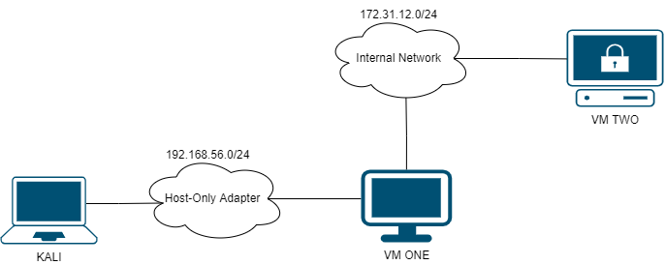

- Your team will be provided with 4 different OVA packages, with each package consisting of two unique Virtual Machines. Each team member is to choose only 1 package out of the 4.

- You are to apply any suitable ethical hacking methodology; to detect and exploit as many vulnerabilities as possible of the various parts of the target and then provide suitable recommendations to remediate the vulnerabilities.

- Marks will be awarded for:

- Well-formatted and structured report with minimal grammatical errors

- Well documented project scope and details of the engagement

- Clear and concise executive summary that provides high level overview of the entire engagement

- Well documented testing methodology and vulnerabilities covered for the engagement

- Findings Overview that provides an overview of all the findings

- Findings include different level of severity for vulnerabilities (Informational, Low, Medium, High and Critical)

- Similar vulnerabilities are grouped under one finding

- Clear and concise description and explanation of the finding with respect to Confidentiality, Integrity, Availability, and business impact

- Appropriate CVSSv3 Risk Ratings (along with the Base Score and CVSSv3 Vectors) assigned for each finding. Temporal Score is optional

- Well documented repeatable steps to identify and exploit the type of vulnerabilities to demonstrate the impact of the vulnerability

- Recommended steps to remediate the vulnerabilities or minimise the risk from various perspectives – prevention, mitigation and detection, short term, and long term etc.

- Well documented affected assets such as IP addresses, ports, URLs, and parameters for each finding

- Appropriate and relevant references for each finding such as CWE, CAPEC, CVE or any resources that will help the reader understand the vulnerability and apply the recommendations to remediate it

- You are strongly encouraged to search for as many unique types of exploitable vulnerabilities as possible and using a variety of tools if you want to do well in this project. Do not document vulnerabilities that you are unable to exploit it!

- Each member is to document a minimum of 2 and up to a maximum of 3 unique vulnerabilities. If a member has submitted more than 3 vulnerabilities, only the first 3 vulnerabilities (based on the report order) will be marked.

- You are NOT to perform vulnerability assessments beyond the scope given, such as scanning other networks and systems. Anyone caught doing so could result in immediate failure of this subject or even more severe disciplinary action.

Project Report Requirements

The final report must contain but not limited to the below sections in the following order:

- Report Cover Page

- Declaration of Non-plagiarism

- Document Control

- Project Scope

- Executive Summary

- Findings Overview

- Detailed Findings and Recommendations (consolidated)

- Test Methodology

- Limitations

See the Project Report Template for more details.

Please follow the following naming convention when you provide the softcopy of your final report to your tutor. There should only be 1 unified report (remember that you are working in a group!). Details of the submission process will be described in 1.4. Submission Instructions

Be warned that plagiarism is a serious offence!

Late submissions:

  - Late and < 1 day: 10% deduction from absolute mark given for the assignment. E.g., 75 marks (100 marks max) à 65 marks (10% of 100 marks).

  - Late ≥ 1 and < 2 days: 20% deduction from absolute mark.

  - Late ≥ 2 days: No marks awarded.

Submission Instructions

        - When generating the PDF report, ensure that the headings are used as bookmarks as shown in the following screenshots:

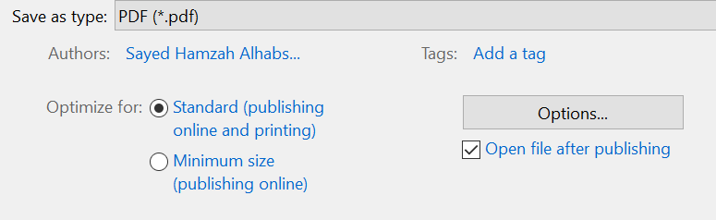

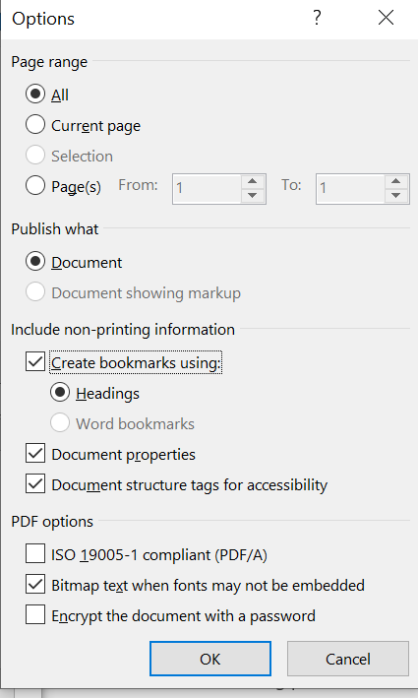

        - Ensure that the report submitted is a PDF file with the following naming convention:

- EHIP-CS-Pxx-Gyy.pdf (xx is your Practical Group number, yy is your Project Group Number)

        - Students are to submit their report via Brightspace LMS based on the stipulated deadline specified in the Teaching Plan. Submissions via any other communication channels (e.g Emails, WhatsApp) will not be accepted.

Presentation Requirements

- Students are to be properly attired during the presentation.

- Each group will be given approximately 30 minutes for their presentation, and you will only be using your Report as your presentation aid.

- The procedure for the presentation will be the following:

- Presentation of one finding per student (chosen by the student prior to presentation)

- Question & Answer session after the presentation

- Marks are awarded based on the following:

- Level of Professionalism

- Ability to articulate background and business impact

- Ability to defend risk rating

- Ability to give recommendations from multiple perspective/limitation

Marking Rubric

